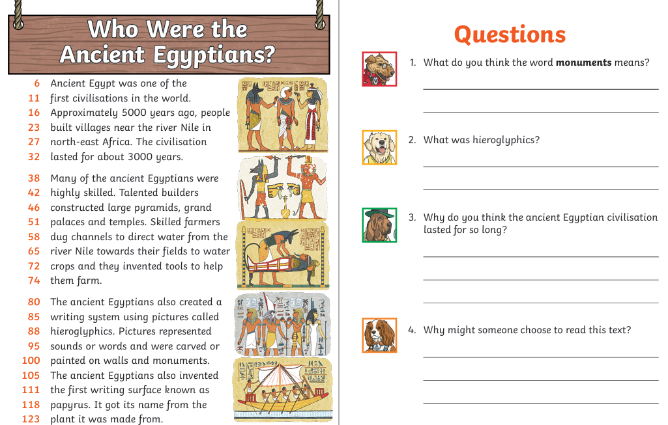
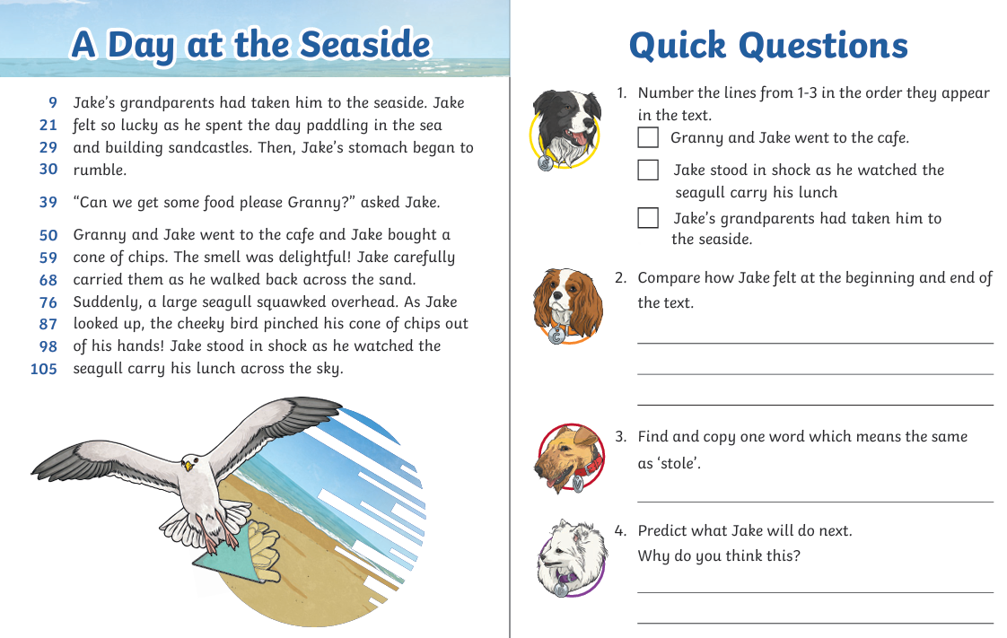
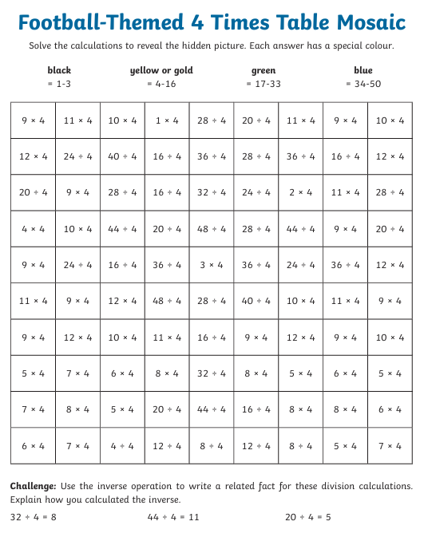

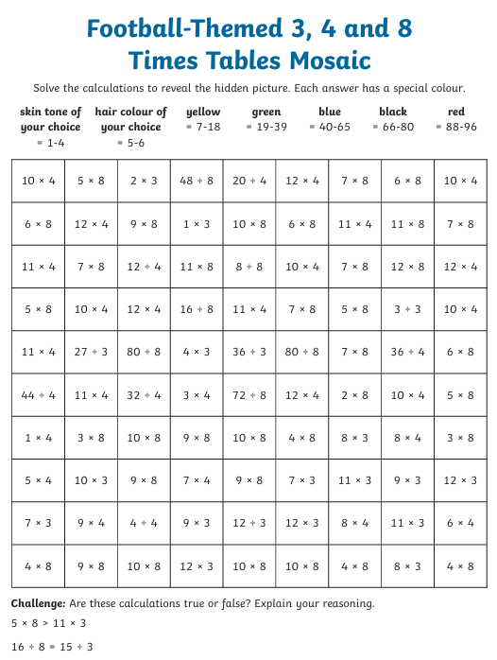

National Writing Day – 23rd June 2026
Write an alternative story from the cover of another book. Think about which characters you might include, what might happen in your story and what genre it is.

The book I have chosen is _______________________________________________.

My story:

___________________________________________________________________________
___________________________________________________________________________
___________________________________________________________________________
___________________________________________________________________________
___________________________________________________________________________
___________________________________________________________________________
___________________________________________________________________________
___________________________________________________________________________
___________________________________________________________________________
___________________________________________________________________________
___________________________________________________________________________
___________________________________________________________________________
___________________________________________________________________________
___________________________________________________________________________
___________________________________________________________________________
___________________________________________________________________________
___________________________________________________________________________
___________________________________________________________________________
___________________________________________________________________________
___________________________________________________________________________
___________________________________________________________________________

